https://easydata.sbp.org.pk/apex/f?p=10:211:11417931055048::NO:RP:P211_DATASET_TYPE_CODE,P211_PAGE_ID:TS_GP_IR_SIRPR_AH,1&cs=1DBDF9690B5B7F30897BB1F56DA14DABF 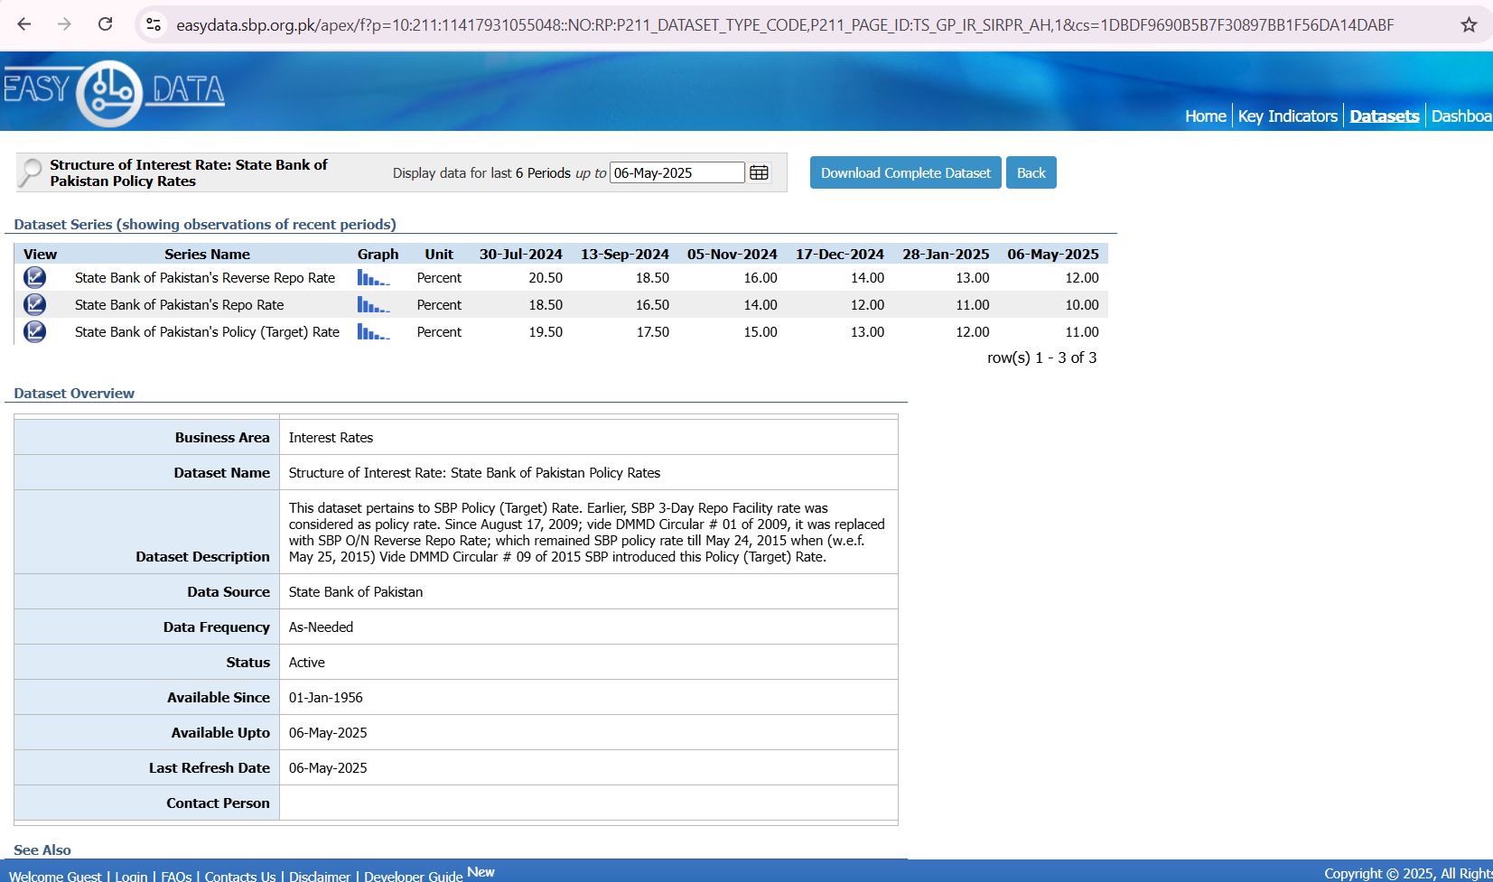
https://data.worldbank.org/indicator/NE.GDI.TOTL.KD.ZG?locations=PK
